Digital Earth Australia Sandbox

Fire Severity Tool

User Manual

Francis, L

October 2023

Arthur Rylah Institute for Environmental Research
Software User Manual

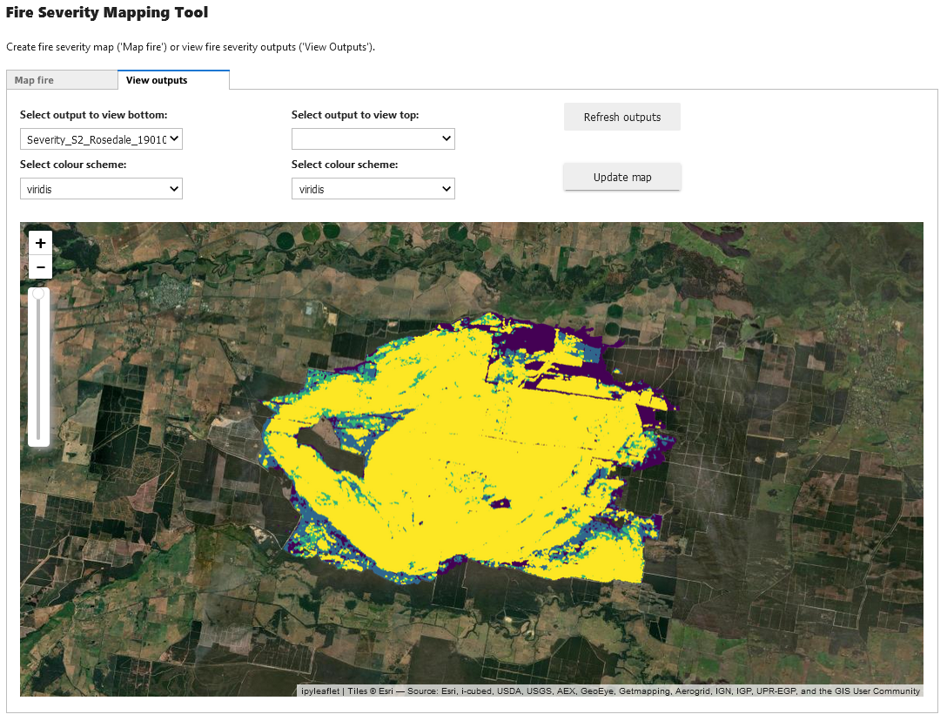



Arthur Rylah Institute for Environmental Research
Department of Energy, Environment and Climate Action
PO Box 137
Heidelberg, Victoria 3084
Phone (03) 9450 8600
Website: www.ari.vic.gov.au
Citation: Francis, A (2023) Digital Earth Australia Fire Severity Tool – User Manual, Arthur Rylah Institute for Environmental Research, Department of Energy, Environment and Climate Action, Heidelberg, Victoria.
Front cover photo: Screenshot of Fire Severity Mapping tool
© The State of Victoria Department of Energy, Environment and Climate Action 2023

Disclaimer
This publication may be of assistance to you but the State of Victoria and its employees do not guarantee that the publication is without flaw of any kind or is wholly appropriate for your particular purposes and therefore disclaims all liability for any error, loss or other consequence which may arise from you relying on any information in this publication.

Acknowledgment
We acknowledge and respect Victorian Traditional Owners as the original custodians of Victoria's land and waters, their unique ability to care for Country and deep spiritual connection to it. We honour Elders past and present whose knowledge and wisdom has ensured the continuation of culture and traditional practices.
We are committed to genuinely partner, and meaningfully engage, with Victoria's Traditional Owners and Aboriginal communities to support the protection of Country, the maintenance of spiritual and cultural practices and their broader aspirations in the 21st century and beyond.

Preface
This tool is a new version of the original fire severity mapping work done by Luke Collins (La Trobe University and Arthur Rylah Institute), and subsequently built on by scientists at the Arthur Rylah Institute. The underlying models and data are the same, however the data is generated to suit Geoscience Australia’s Digital Earth Australia Sandbox environment.
This work advances the tool in the generation combined outputs, ensembling the Landsat and Sentinel fire severity outputs into a single output dataset. This allows users to get imagery best suited to model performance and minimise missing data due to cloudiness.
The following pages detail the user interface for the tool and how to generate fire severity maps from it. For model specific details, refer to:
Collins, L., Griffioen, P. and Newell, G. (2020). Fire severity mapping across Victoria using Random Forest and satellite imagery. Unpublished Report for Forest, Fire and Regions, DELWP. Arthur Rylah Institute for Environmental Research, Department of Environment, Land, Water and Planning, Heidelberg, Victoria.

We would like to thank Naomi Withers and Luke Smith from the Department of Environment, Energy and Climate Action for their support on this and prior fire severity projects. This research was funded by Forest, Fire and Regions under the ARI-PPD project agreement.

- DEA Sandbox Startup interface
When logging into the Digital Earth Australia (DEA) sandbox, you will be met with the below interface.

5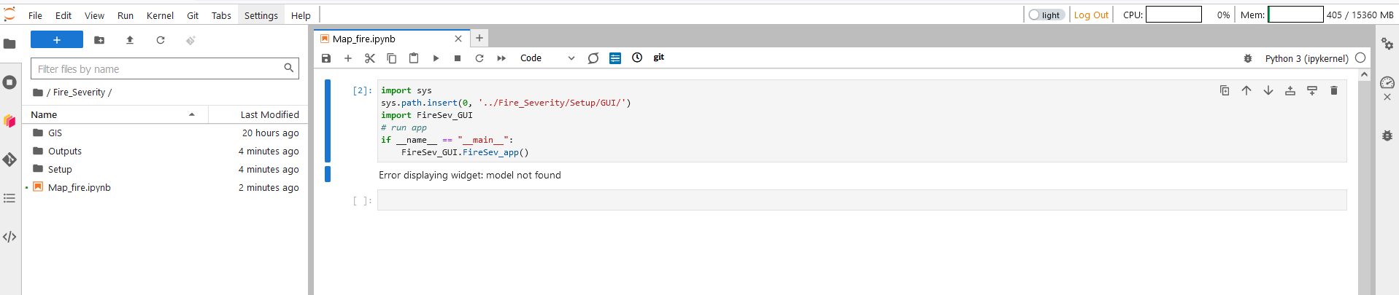
4
3
1
2
Figure 1: DEA Sandbox Fire Severity environment

1 | File explorer panel. Drag and drop files here, right-click on files to download .
2 | Jupyter notebook. Map_fire.ipynb contains code to launch the fire severity app. Run cell by first selecting the cell (click inside cell so cursor appears), then by selecting Run>Run selected cells from the top drop down menu, or by pressing Shift + Enter.
3 | CPU load. During fire severity mapping, this should fluctuate and indicates that there are computations in progress.
4 | Available memory. During fire severity mapping, this should increase depending on the amount of data to process. If your mapping area is too large and or your imagery windows are too large, you may run out of memory. A pop-up will appear saying the kernel has closed unexpectedly if you run out of memory.
5 | A toggle to switch between light and dark screen modes.

Select the Map_fire.ipynb from within the Fire_Severity folder, and run the first cell. Once you have run the cell within Map_fire.ipynb, the fire severity mapping tool interface will appear (Figure 2).
- Initial Fire Severity Mapping Tool startup
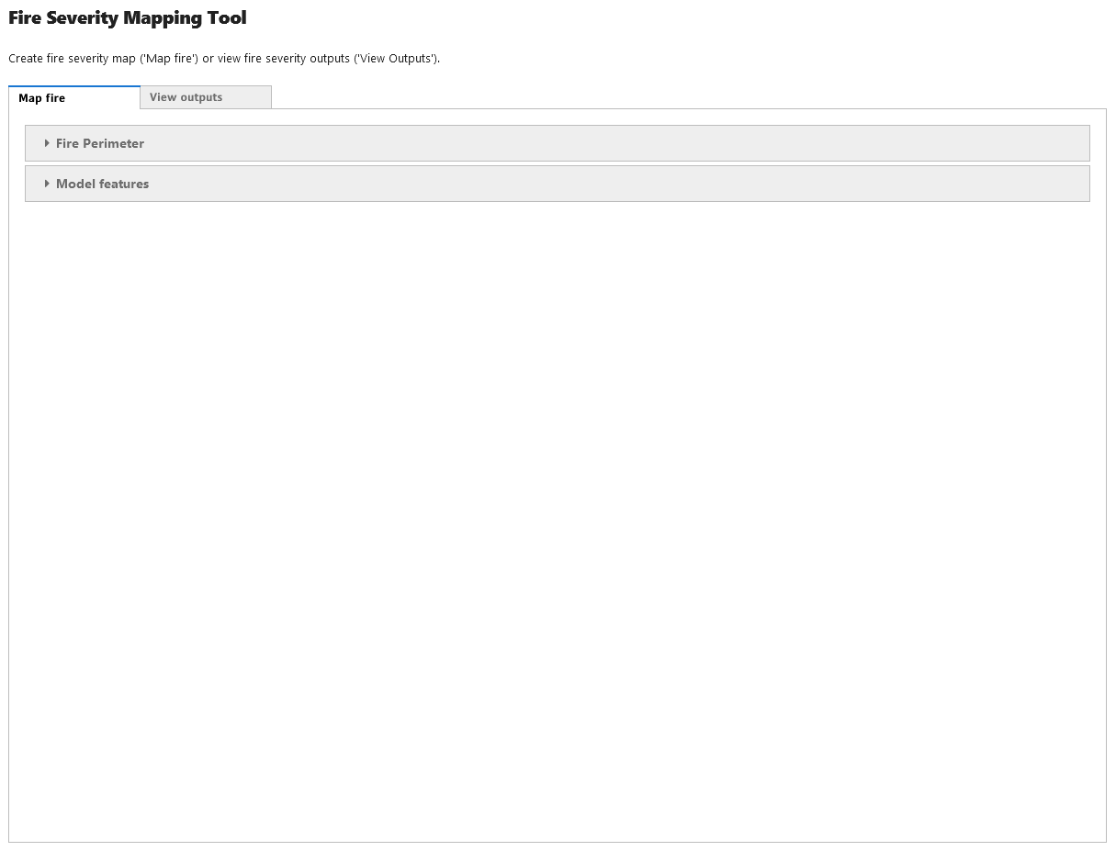
9
8
7
6
Figure 2: The Fire Severity Mapping Tool startup interface

6 | The interface tab for generating fire severity mapping
7 | The interface tab for viewing fire severity mapping outputs within the Sandbox environment
8 | The interface menu for selecting or drawing the fire perimeter and inputting fire metadata, including fire start and end dates
9 | The interface menu for selecting the model specifics, e.g. satellite, planned burn data etc

To start the fire severity mapping process, select the Fire Perimeter (Figure 3) menu to select or draw your fire boundary and input the fire metadata if known.

- Fire perimeter and metadata
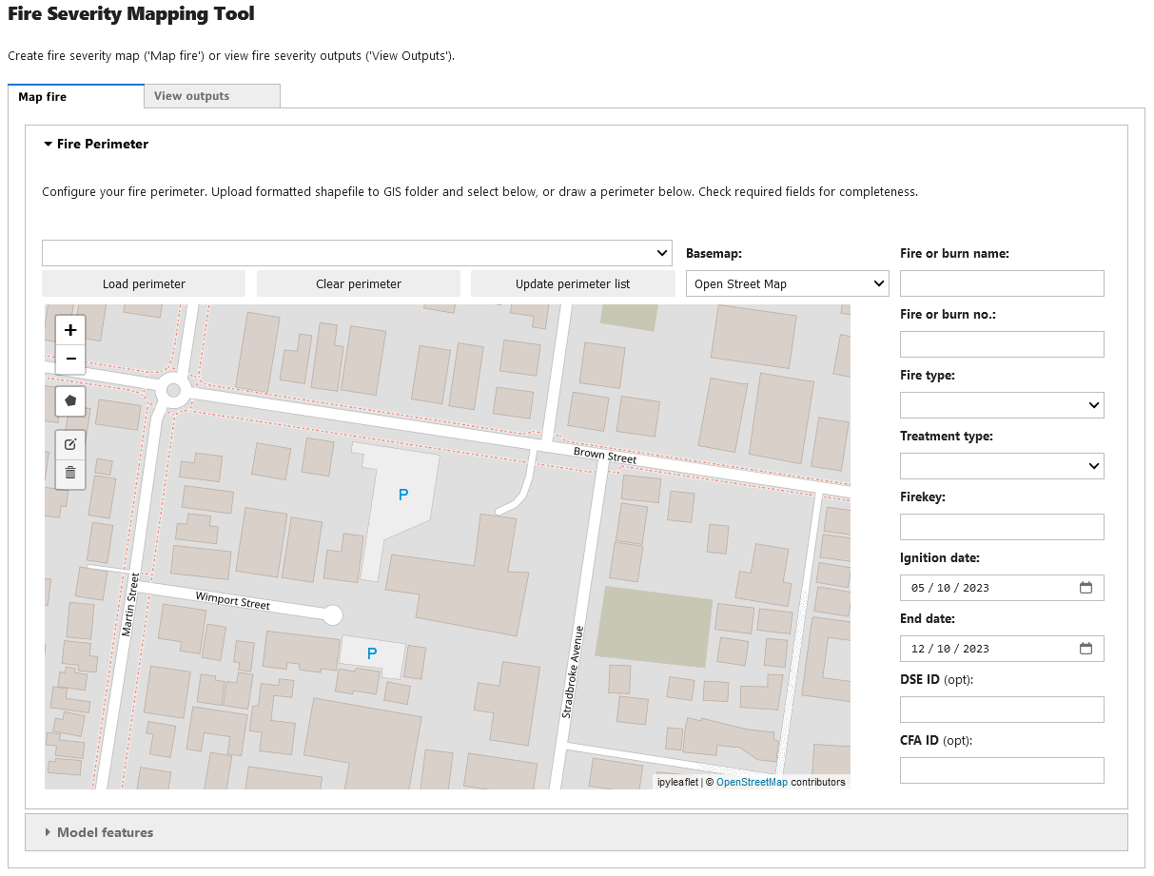
155
25
24
23
22
21
20
19
18
17
16
14
13
12
11
Figure 3: Fire perimeter and metadata details

11 | Select your perimeter if uploaded into Fire_Severity/GIS folder. Any files uploaded after the app was initialised will not be seen here until you click ‘Update perimeter list’
12 | Load the fire perimeter into the map to review. If the shapefile is correctly formatted, the metadata inputs on the right will also be automatically updated. This will also clear any content within the map.
13 | Clears the perimeter from the map (selecting another map and loading will also clear the existing loaded perimeter).
14 | If you upload your perimeter to the Fire_Severity/GIS folder after launching the app, this button refreshes the drop-down menu and new additions are now available for selection
15 | Draw your own perimeter or add to an uploaded perimeter. Up to two additional polygons can be drawn. All polygons are merged (either uploaded or drawn), so any overlap will be absorbed during merger.
16 | Change the background map between street maps and aerial imagery
17-25 | Fire metadata information to be carried through to the output shapefiles (all optional)
17 | The name of the fire. This name will be used to name the output files and identify the fire in the metadata outputs.
22 | This date is the ignition date used to generate the imagery
23 | This date is the end date used to generate the imagery

Upload or draw your fire perimeter and input the fire’s metadata. If the template in Fire_Severity/GIS/Template is used, data in the attribute columns will automatically fill the metadata inputs. If uploading your own shapefile, the coordinates system the file is in won’t affect the software. Once you have completed this, select model features (Figure 4) and map the fire.

- Fire severity model feature selection
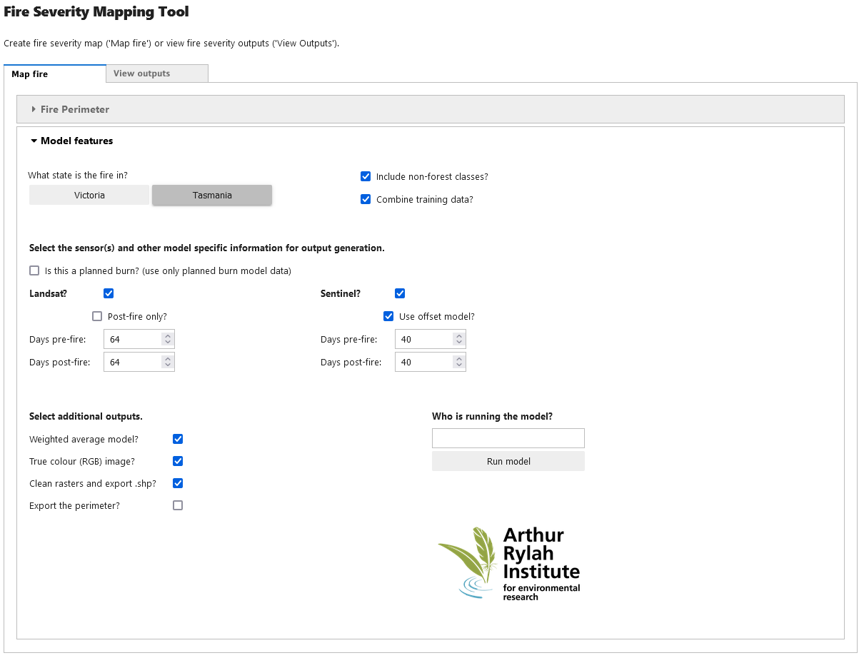
39
38
37
36
35
34
33
32
31
30
29
28

Figure 4: Fire severity model details

28 | Select the stat the fire is in. Tasmania if selected has two additional options (29, 30)
29 | Select if fire contains potential non-forest vegetation communities (i.e. buttongrass)
30 | Select if you wish to combine Tasmanian training data with Victorian training data
31 | Select if want the training data to be on from planned burns.
32 | Landsat selection. Select if you want Landsat based fire severity. Post-fire only is if you want the model to use only post-fire data. Days pre and post-fire are used to collate the imagery. Default 64 days is recommended before expanding if cloud gaps remain.
33 | Sentinel selection. Select if you want Sentinel based fire severity. Offset model is if you want to use the model which uses a buffer of woody vegetation to account for seasonal changes during the fire (recommended). Days pre and post-fire are used to collate the imagery. Default 40 days is recommended before expanding if cloud gaps remain.
34 | Create a weighted average model if you wish to combine the Landsat and Sentinel fire severity maps to generate a composite fire severity map (recommended). This can fill cloud gaps between the sensors and retain better model results before expanding the pre and post-fire windows. It combines the outputs at the Landsat spatial scale.
35 | Select if you want a median post-fire true colour image for any satellites selected.
36 | Select if you want output rasters to be post-processed and shapefiles generated from the cleaned rasters. Shapefiles contain the metadata input in Fire Perimeter interface
37 | Select if you want the perimeter used to be exported as a shapefile, useful if you have modified an existing or drawn your own perimeter
38 | Who is running the severity mapping. This name gets inserted into the metadata and the shapefile (if shapefile is requested).
39 | Run the fire severity model when you are happy with the selected inputs

Each time the fire severity model is run, the software creates the Random Forest machine learning model to suit the users inputs. For Tasmanian users, it is recommended to combine the Tasmanian and Victorian training data (30). If the fire severity is for a planned burn, the training data can be subset to use data from planned burns only (31).
For Landsat mapping, post-fire mapping only is not recommended unless you have considerable trouble getting cloud free imagery, but this will only be beneficial if the cloudiness is pre-fire.
For Sentinel mapping, is it recommended to use the offset model. The offset model uses some spectral indices which account for any seasonal affects during the fire (e.g. forest drying).
The weighted average model combines both satellite derived severity maps, matching the spatial resolution of Landsat imagery (30m square pixels). The weighted average accounts for each sensor derived model’s output and probability when combining.
The raster cleaning process matches existing Victorian post-processing routines. This process is based on some focal statistics of the rasters. Using 3x3 pixel moving windows, the cleaned raster will take the Canopy Burnt class if it is the maximum value in the 3x3 window, else it will then look to fill it with the majority value within that 3x3 window. Should there be multiple modal values, the lowest value will be taken unless the centre pixel original value is in the list, then the centre value will be retained. The output rasters retain numerical values, from which the fire severity classes are given in the metadata file output.
The metadata output is a text file that accompanies the outputs. It contains all the necessary information used to create the fire severity map for transparency and reproduction.
Output shapefiles are generated from the cleaned rasters. The raster numerical severity classes are converted back to fire severity classes. No spatial aggregating or smoothing is undertaken.

- Fire severity output viewer
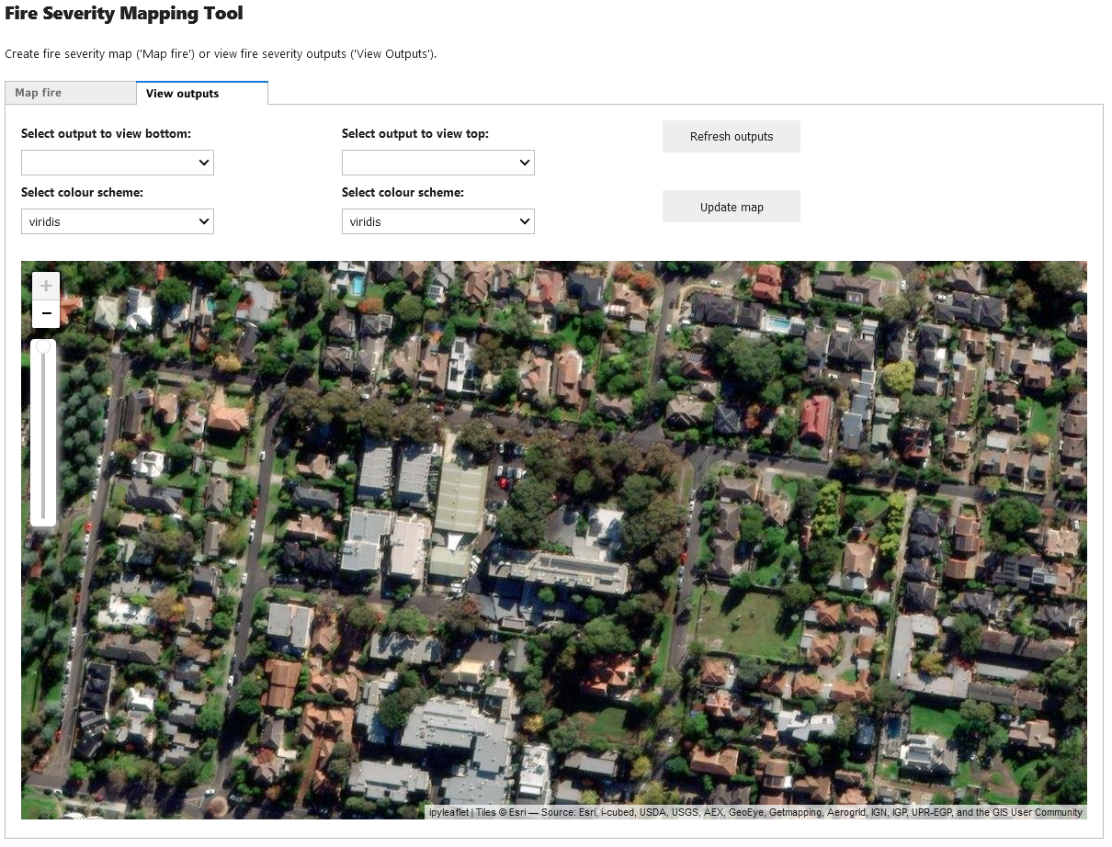
45
43
44
42
41
41
40
Figure 5: Sandbox environment output viewer

40 | Select a raster to load into the map. If two rasters are loaded, this will be the bottom raster
41 | Select a colour scheme for the above raster if it is not a true colour satellite image
42 | Select a raster to load into the map. If two rasters are loaded, this will be the top raster
43 | Click to refresh the available outputs to display
44 | Load the selected outputs into the map
45 | This slider controls the opacity of the top raster. If there is only one raster loaded, it controls the opacity of that raster

This viewer is to enable users to quickly review their outputs prior to download or re-run the model with different settings.
As the application has usually been running to generate the outputs, you will likely have to refresh the dropdown options (43) when you move to view your model outputs.
You can select two different outputs to view and compare the results with. If you select two, the opacity slider on the left (45) will control the opacity of the top raster to quicky compare different areas between the selected rasters.
Once you are happy with the results, model outputs can be downloaded from the Fire_Severity/Outputs folder by selecting the outputs, and right clicking and selecting download.

www.deeca.vic.gov.au

www.ari.vic.gov.au

