QR code tool
How to access the QR code tool

Type into the browser window
Apps.ffm.vic.gov.au
The login screen will open, type in your Fireweb username and Password and then click on the arrow
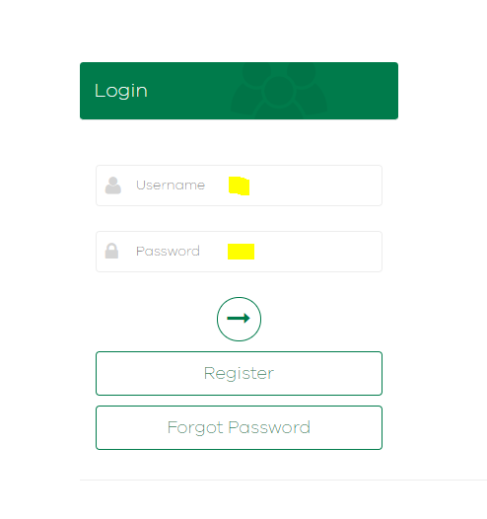
The FFMVIC Apps page will open. Click on the QR code button to open the app.

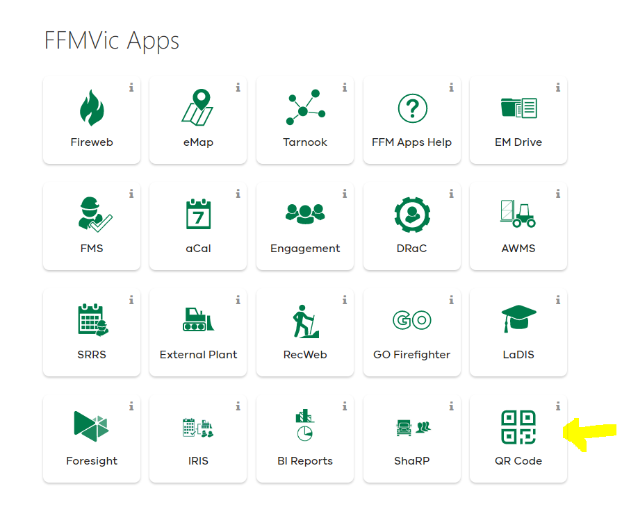
Enter your Fireweb username and password
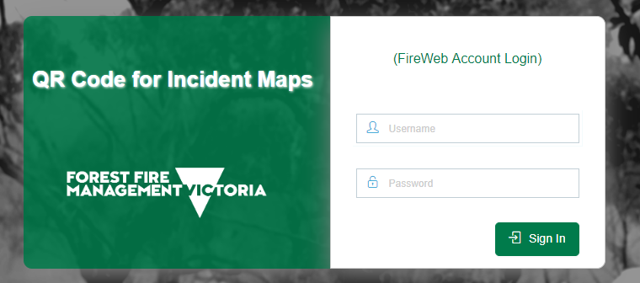
The Home page for the QR code for Incident maps will open
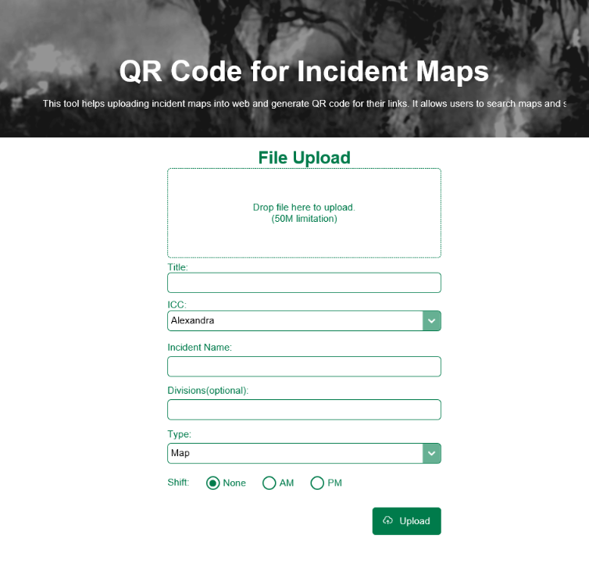
How to upload a new map
Drag and drop a file into the File Upload window for a new map
(if you are using EMDrive – download the pdf you are uploading first)
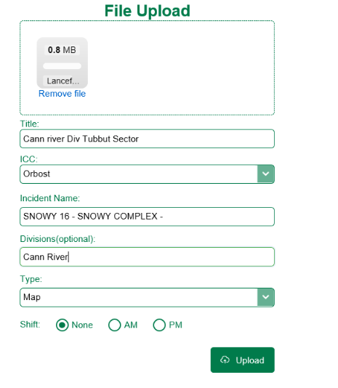
If you have dragged the wrong file into the File Upload window, you can select Remove file to delete the file.

Give the map a title – use the naming convention Date, ICC, incident, size and scale


Select the ICC from the pick list
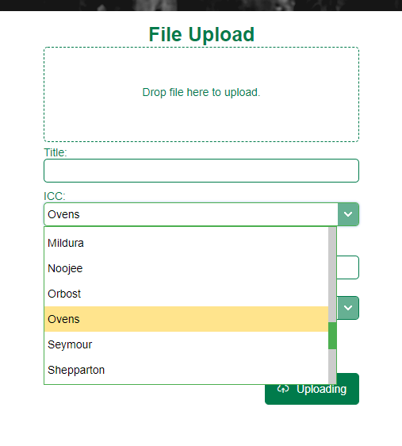
Select the Incident name - start typing and a dropdown list will appear of incidents from Fireweb
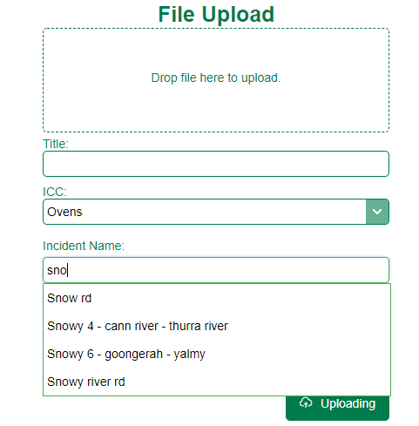
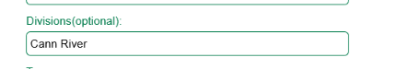
Type in the Division name if there are Divisions
Select the Type of document: either a pdf map or a doc eg a word or excel document eg IAP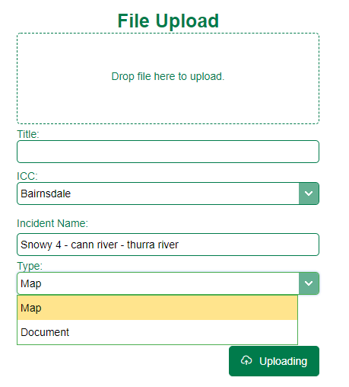

Select whether the document is attached to a Shift (AM or PM) or None.
Then click on the Uploading button.

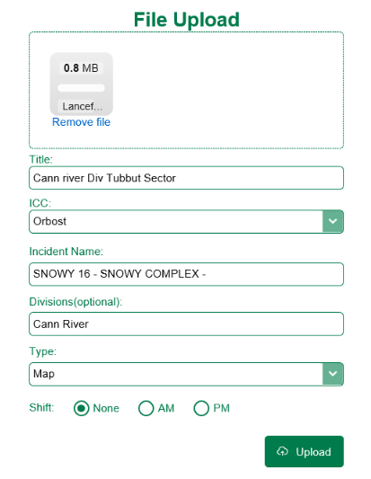
Map Catalog
The map catalog is ordered with the most recent updates showing first.
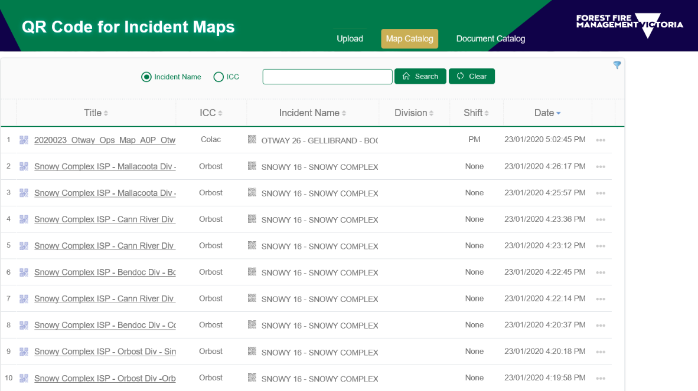

If you click on the QR code next to the title, it will open the QR code.
This can be snipped and added to a map template or an ISP. This QR code is unique for the map title.
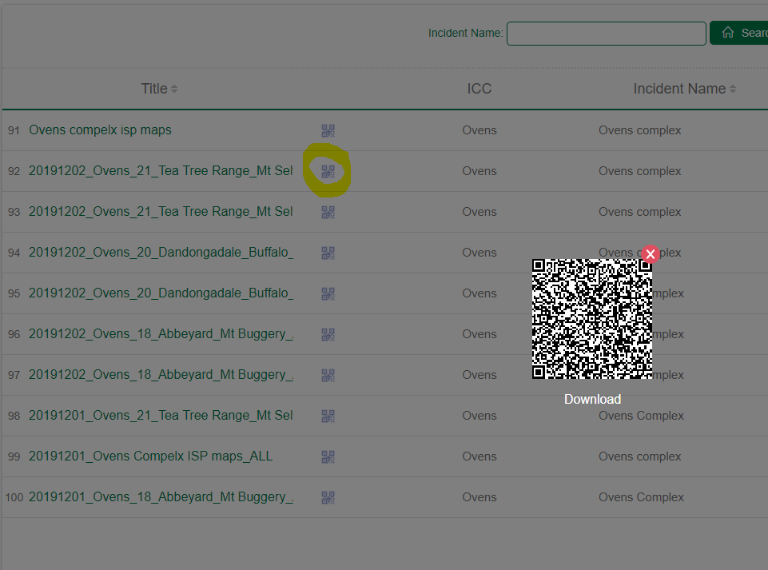
The next field is the ICC, showing which ICC the map has been assigned to.
The Incident name is next, and is determined by the naming of incidents in Fireweb. Only Incidents in Fireweb are listed, so no random naming occurs.
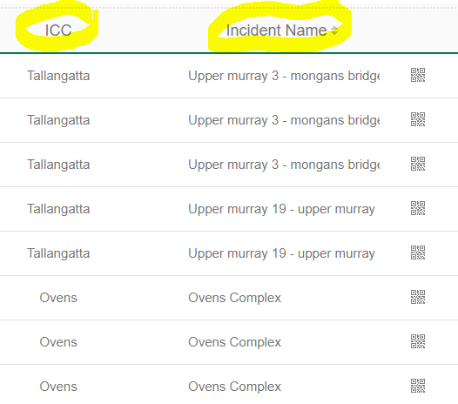

If you click on the QR code next to the Incident Name, this will open the QR code associated with the folder for that incident.
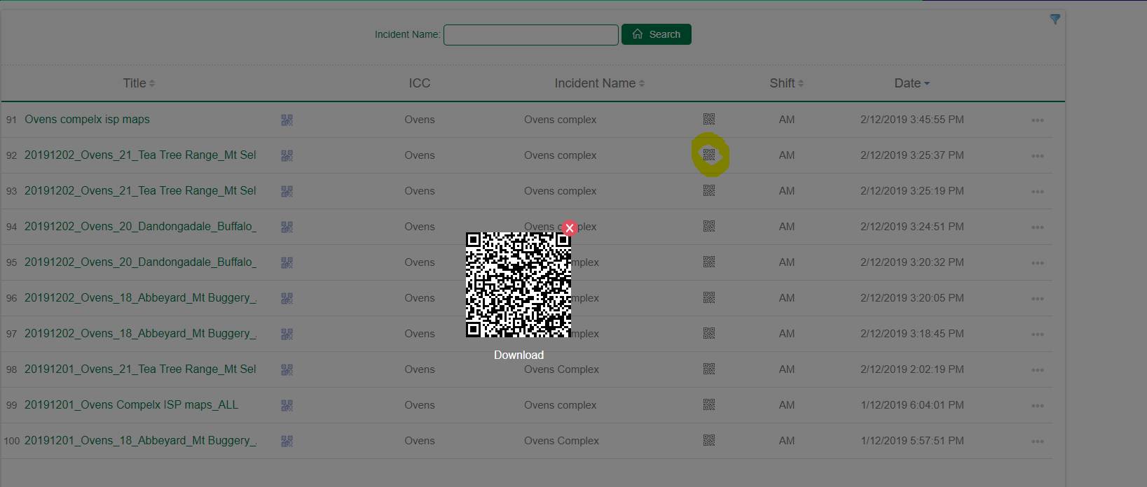
This can be scanned by a QR reader and it will open on your mobile device.
The Division is also included. There will be a QR code associated with the Division soon and searching capability. 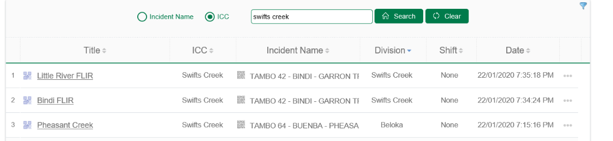

Scanning QR codes.
Or you can open Avenza and click on the + symbol at the top to open the Import Maps interface.
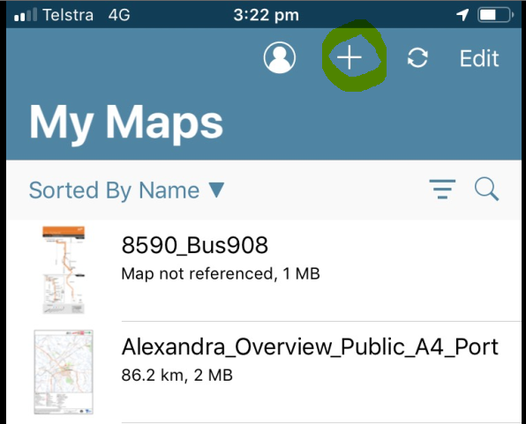
On the Import maps interface, Click on the QR code tool which is highlighted to scan the QR code.
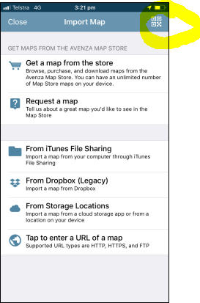
This will open the scanner.
Scan the individual map QR code or the Incident QR code and it will open the file sharesite. Click on Maps Folder and it will open the Incident folder.

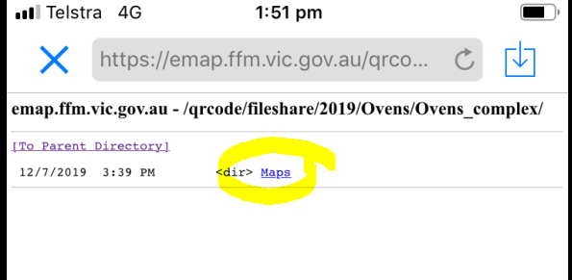
The user can then select the specific pdf files from that Incident
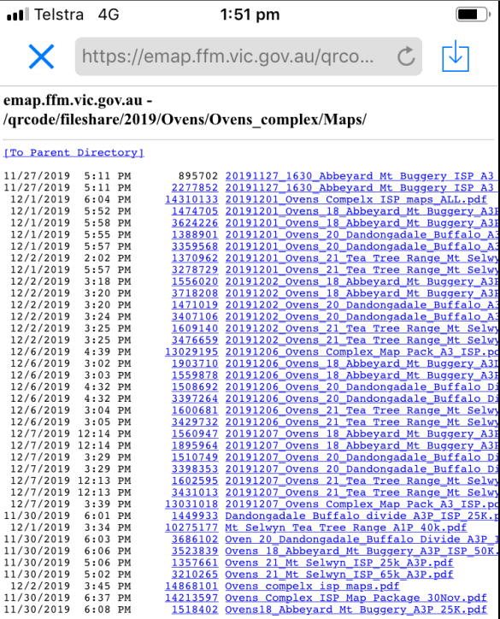
Click on a pdf link and it should automatically open in Avenza.
Do not group pdf maps as a mappack, as they will not opencorrectly in Avenza. Each map needs to be loaded separately. The maps are grouped in the incident folder. This will allow them to be correctly georeferenced in Avenza.
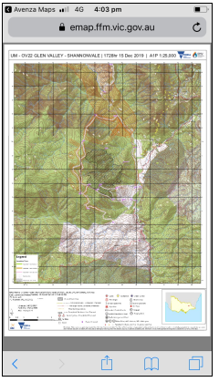

How to update Maps in the QR code tool
Click on the 3 dots on the right hand side of the table associated with the map you want to edit. This opens up a tool which allows you to Update the map.
Select Update and it opens a dialog which allows you to drop the updated file
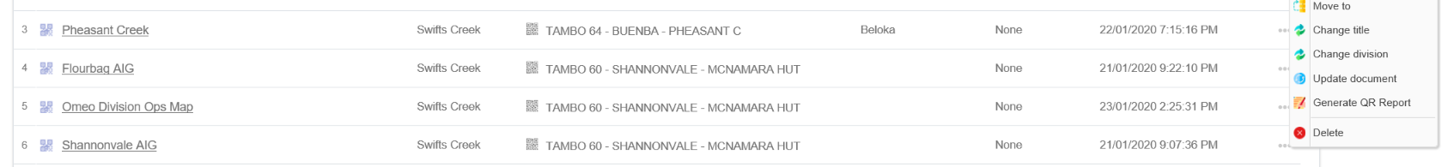
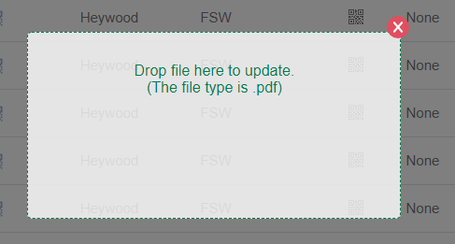
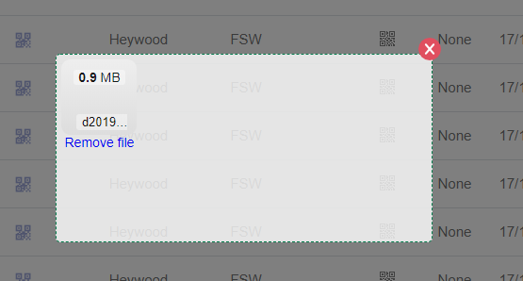

The update process will automatically update the date and time for this file.
How to update Maps in the QR code tool
Click on the 3 dots on the right hand side of the table associated with the map/doc you want to delete. This opens up a tool which allows you to delete the pdf.
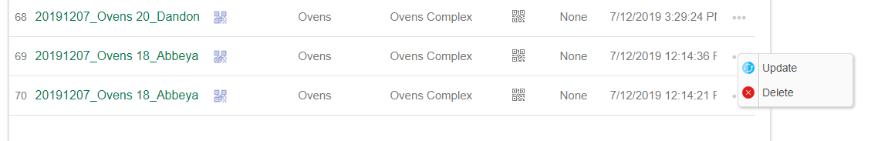
Click on delete and this opens up a dialog which allows you to delete the pdf. Select OK.
The file will be deleted.
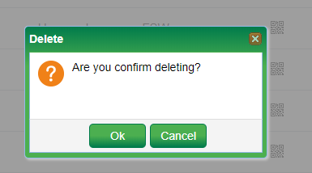
How to move a document
Click on the 3 dots on the right hand side of the table associated with the map/doc you want to move. This opens up a tool which allows you to move the document to a new Incident eg when fires are merged into a complex.
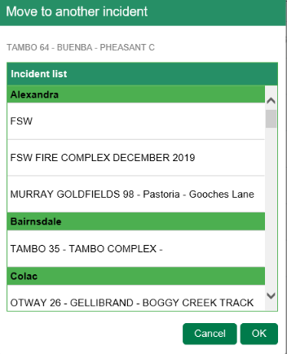

How to change the title of a map or document
Click on the 3 dots on the right hand side of the table associated with the map/doc you want to change the title of. This opens up a tool which allows you to change the title of the document or map.
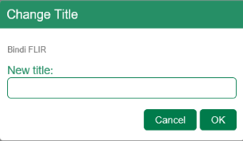
Type in the new title and select OK.
How to Change Division
Click on the 3 dots on the right hand side of the table associated with the map/doc you want to change the Division it sits within.
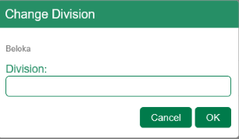
How to Generate QR report
Click on the 3 dots on the right hand side of the table associated with the map/doc you want to generate the QR report for.
The incident name is listed, give the report a title and select Generate.
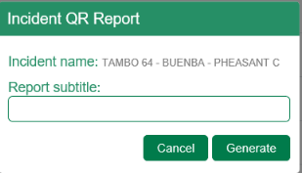
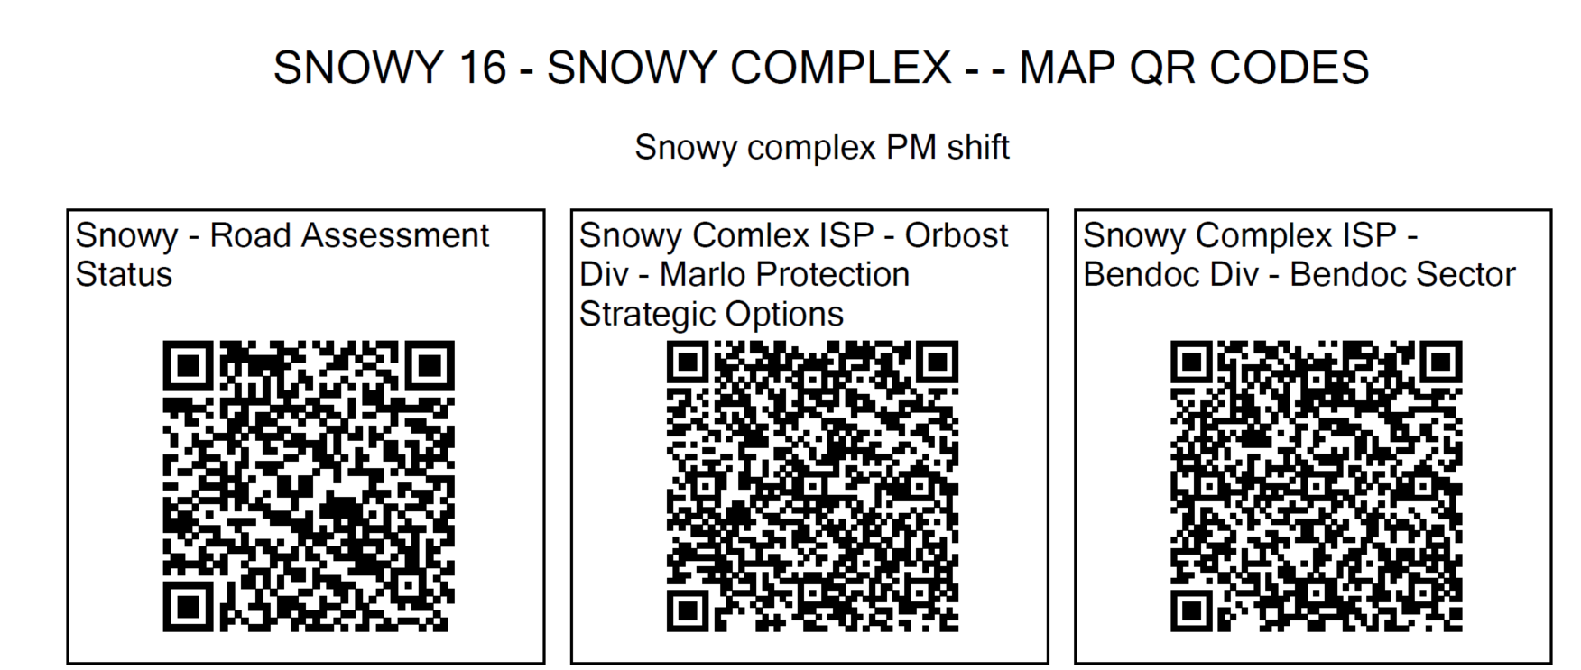
This report can be inserted directly into the ISP.

Document Catalog
The document catalog works in the same way as the map catalog for uploading, updating and deleting files.

