This is the GEE user interface.
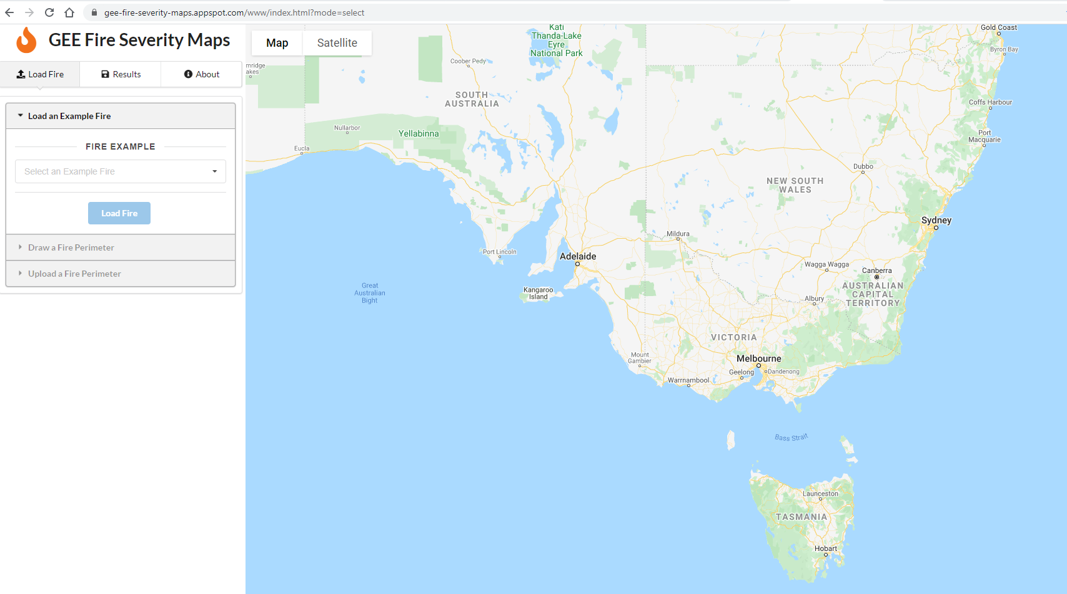
Under the Load Fire tab.
Click on Draw a Fire Perimeter tab
This open the workflow to draw a fire perimeter.
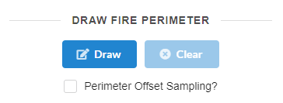
Click on the Draw button to open the editing tool. Zoom to the location where you want to draw the shape. To start drawing right click the mouse button, then click the vertices to create the polygon, then close the shape by clicking on the start point.
If you are unhappy with your polygon you can click on the Clear button to remove it.
You can select the Perimeter Offset sampling button, the tool samples the data past the drawn boundary and creates a buffer around the shape.
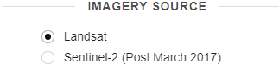
Once you have created a shape you are happy with, select the imagery source. Landsat data has access to data going back 40 years.
Sentinel-2 data is only available from March 2017.
https://earthengine.google.com/faq/

Select the data source you want to use for your analysis.

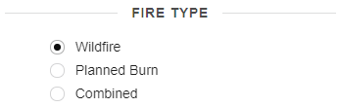

Select the Fire type.
NB. Please remember this algorithm has been trained specifically for either Wildfires or Planned burning data.
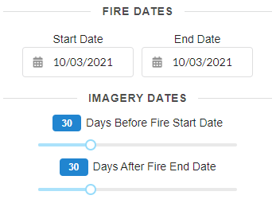
When selecting the dates, for a bushfire, select the date the fire started, and if it was a campaign fire, try to determine an end date that is appropriate.
For planned burns select the start date and the day the fire goes to patrolled or Safe.
With the time slider, select the number of days prior, this will allow the identification of an image that is cloud free, and it is preferable to get imagery in the same season to ensure image consistency.
For the time slider post fire, please consider when trees start to regenerate and shoot, which potentially may impact on the quality of the result. 30-60 days is recommended. In Tasmania, with less cloud free days this time period may need to be extended to 100 days.
The tool will not work, if you select a time period which is in the future.
Eg if the fire was 7 days ago, the time slider can only use imagery from 5 days ago, as it moves in increments of 5 days.

Once all these parameters have been selected, please click the Load button.

