Using Context Cam to submit field photos to eMap
December 2020

What is Context Cam?
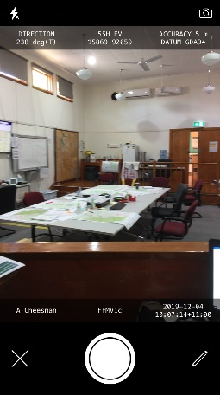
Context Cam is a mobile app that allows image metadata to be overlaid on a photo. This metadata (location, direction, date, time, person) allows images to be validated and provides valuable intelligence for Incident Management Teams.
Context Cam images can be loaded into eMap and will display in a similar fashion to AIG and Firemapper images.
To load Context Cam images to eMap, you will need the following:
- Context Cam app (purchased app)
- CTERA mobile app for accessing EM-drive
- EM-drive login credentials

Loading and configuring Context Cam
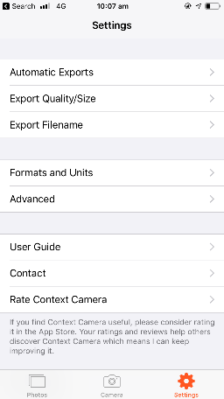
Firstly, purchase the Context Cam app from the App Store.
Once you have purchased the app, you will need to configure the app to save captured images in your photo library. To do this:
- Go to Settings > Automatic Exports
- Set ‘Export Photo’ to Destination ‘Photo Library’
You will also need to configure overlay options for the app. To do this:
- Go to Camera page
- Hit Pencil icon
- Configure Option 1 and Option 2 (Option 1 should be your name, Option 2 should be Agency (eg FFMVic) or role (eg Air Observer)
Once these settings are configured, you will be able to take photos using the Context Cam app, and these photos will automatically appear in your Photo Library.
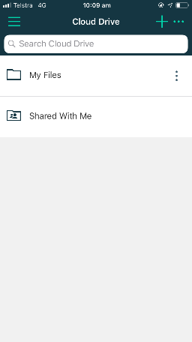

Loading and configuring CTERA
CTERA is a mobile app that allows you to access EM-drive from your mobile device. Once installing the app, you’ll need to configure the app as follows:
- Server address is emdrive.ffm.vic.gov.au
- Sign in credentials are your Fireweb username and password.
- Note that due to recent updates to EMdrive and updates to the CTERA app, you may find that the CTERA app is not allowing you to log into EMdrive. If this is the case, you need to delete the CTERA app from your phone and then re-load the app from the App Store.

Saving photos to CTERA
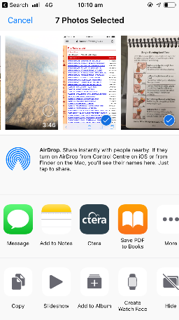
Once you have installed CTERA, it is very easy to share photos directly from your Photo Library directly to a folder location on EM-drive. To do this:
- From your photo library, tap ‘select’ (top RH corner) and then tap to select the photos you wish to save to EM-drive
- Tap the ‘Send To’ icon in bottom LH corner (square with up-arrow)
- From the list of apps available to you, select CTERA. For first use, you may need to add CTERA to this list. To do this, select ‘More’ and then turn on the CTERA app from the list.
- The CTERA app will open and you will need to select the location you wish to save the photos to. Once you have selected the location, tap ‘Upload’ in the top RH corner.
- For photos to publish to eMap, photos need to be saved to Shared With Me > EM Drive > 60 – Reference > Mapping > _FieldPhotos
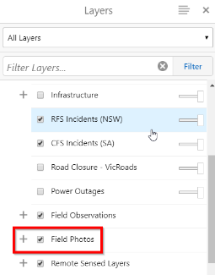
- To save time, this folder location can be ‘shared’ with you by another user. This will then make the folder available in your ‘My Files’ section of CTERA.

Accessing photos from eMap
Once photos have been submitted to CTERA, they will be made available in eMap and Image Viewer within 5 minutes.
- In eMap, CTERA photo points will be shown when the ‘Field Photos’ layer is turned on, and the photo can be viewed by clicking on the point on the map.
- In eMap Image Viewer, CTERA photo points will be available in the ‘Field Photos’ section when an appropriate date range is selected.

Help and Support
For further information regarding this, please contact:

FFM Support

support@ffm.vic.gov.au
https://servicedesk.ffm.vic.gov.au/servicedesk/customer/portal/4 to log an online support request
Ph 03 9637 9741
For Hume Region enquiries, please contact:
Anthony Cheesman
anthony.cheesman@delwp.vic.gov.au
Ph 0477 314 471

